Password:

Username:

iBorrow

Daily Record

Unreturned Items

Borrow Items

Upon opening the application, a login will be required After logging in, three options will be available. The Daily record

to ensure that only authorized SLU Personnel can use it. will show a list of all the borrowed items together with the people

who borrowed them. Unreturned items will show a list of all

unreturned items. Borrow items will prompt a download of a

borrower’s slip.

DAILY RECORD

Date

UNRETURNED ITEMS

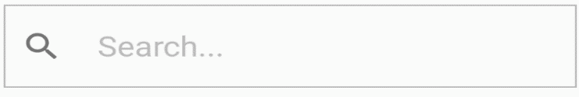

Student

Date Borrowed

GAGELONIA, Jen

1 Bunsen Burner

2 Lighters

LABAN, Joshua

February 16, 2017

March 5, 2017

Student

Status

Returned

Unreturned

Returned

Returned

Unreturned

Returned

Returned

Returned

CRUZ, Dwight

GAGELONIA, Jen

GARCIA, Mark

GENOVE, Sean

LABAN, Joshua

LEONEN, Aerhielle

Ragay, Claudine

ZIPAGAN, Jerome

For the Daily Record, the date will be displayed above the search For the unreturned items, only the name of the borrower and

bar. Daily Records will be kept together with their corresponding the date borrowed will be displayed. Arrows will be placed

status. A search bar can be used if a lot of record has been stored. beside each student’s name. If the arrow is pointing down,

If the custodian puts a status on the search bar, the daily record pressing it will show what items are still unreturned. Pressing

will be sorted according to the input. the arrow pointing up will hide the item/s.

BORROW ITEMS

(Student)

Name:

Schedule:

Subject:

Activity No.:

Student

Image result for up and down arrows black and whiteImage result for up and down arrows black and whiteImage result for up and down arrows black and whiteImage result for up and down arrows black and whiteImage result for up and down arrows black and white

Item

Quantity

Add Item/s

Cancel

Save

2

2

1

1

1

Graduated Cylinder

Flask

Dropper

Ring Stand

Wire Gauze

Instructor

If the user chooses “Borrow Items”, this page will appear which If a student will borrow laboratory equipment, only four fields

will ask if the borrower is a student or an instructor. will be initially filled up. Upon choosing the subject and activity

no., items together with their quantity will be automatically

shown. The student may still ask to add item/s if needed. The

arrowheads show that quantity may be increased or decreased.

Image result for up and down arrows black and whiteImage result for up and down arrows black and white

Department:

ID No.:

Name:

Graduated Cylinder

Lighter

2

4

Item

Quantity

Save

Cancel

Add Item/s

BORROW ITEMS

(Instructor)

If an instructor wished to borrow laboratory equipment, only

three fields will be initially filled up. The arrowheads still signify

that quantity may increase or decrease. However, items will be

manually added.